National Immunization Record System

Will Yang
School of Health Information Science
University of Victoria
March 31st, 2011
Table of Contents

Entity Relationship Diagram 2
Minimum and Maximum Cardinality Description 3
Database Summary 4

Entity Relationship Diagram

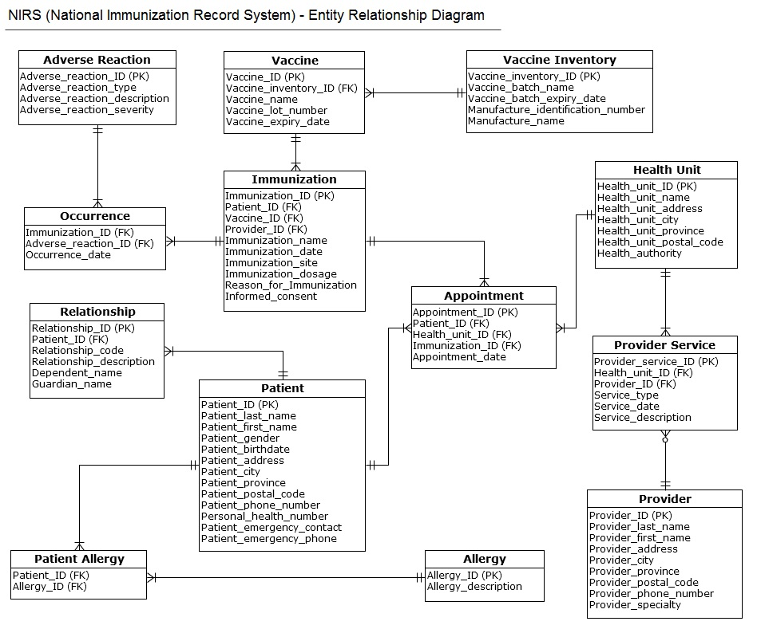

Minimum and Maximum Cardinality Description

- One immunization belongs to only one vaccine; one vaccine contains a minimum of one and a maximum of many immunizations.
- A vaccine belongs to one inventory; one inventory contains a minimum of one and a maximum of many vaccines.
- One appointment has one immunization; one immunization can appear in many appointments.
- One appointment contains one patient; one patient can be in a minimum of one and a maximum of many appointments.
- One appointment includes one health unit; one health unit can be in a minimum of one and a maximum of many appointments.
- One provider service has one provider; a provider provides many services.
- One provider service includes one health unit; a health unit administers a minimum of one and a maximum of many services.
- A patient can have many relationships; a relationship identifies related individuals for one patient.
- A patient allergy has one patient; a patient can have a minimum of one and a maximum of many patient allergy combinations.
- A patient allergy includes one allergy; one allergy appears in patient allergy for a minimum of one and a maximum of many times.
- An occurrence has one and only one immunization; an immunization can have a minimum of one and a maximum of many occurrences.
- An occurrence attaches one and only one adverse reaction; one adverse reaction has a minimum of one and a maximum of many occurrences.

Database Summary
Number of tables: | 13
Number of columns: | 77
Number of foreign keys: | 14
Last build date: | Not built
Tables | Columns | Indexes | Foreign Keys | Notes
Immunization | 10 | 0 | 3 | Contains immunization information (i.e. immunization unique identifier, immunization name, immunization date, patient body site of immunization, immunization dosage, reason for immunization and whether the informed consent has been obtained)
Vaccine | 5 | 0 | 1 | Contains vaccine information (i.e. vaccine unique identifier, vaccine name, vaccine lot number and the expiry date for the vaccine)
Vaccine Inventory | 5 | 0 | 0 | Contains vaccine inventory information (i.e. vaccine inventory unique identifier, the name of the vaccine batch, the expiry date for the vaccine batch, manufacture identification number and manufacture name)
Appointment | 5 | 0 | 3 | Contains detailed information about the appointment (i.e. appointment unique identifier and appointment date)
Health Unit | 7 | 0 | 0 | Contains health unit information (i.e. health unit unique identifier, name, address, city, province, postal code and health unit's health authority name)
Provider Service | 6 | 0 | 2 | Contains detailed information about the service provided by a provider (i.e. provider service unique identifier, service date and service description)
Provider | 9 | 0 | 0 | Contains provider information (i.e. provider unique identifier, provider name, address, city, province, postal code, phone number and provider specialty)
Patient | 13 | 0 | 0 | Contains patient information (i.e. patient unique identifier, patient name, gender, birthdate, address, city, province, postal code, phone number, patient personal health number, patient emergency contact and emergency phone)
Relationship | 6 | 0 | 1 | Contains relationship information between patient and guardian (i.e. relationship unique identifier, relationship code, description, dependent name and guardian name)
Patient Allergy | 2 | 0 | 2 | Contains patient allergy information to avoid the many-to-many relationship between patient and allergy. This table includes a composite key consists of two foreign keys: Patient ID from the patient table and Allergy ID from the allergy table.
Allergy | 2 | 0 | 0 | Contains allergy information (i.e. allergy unique identifier and allergy description)
Occurrence | 3 | 0 | 2 | Contains occurrence information between an immunization and an adverse reaction (i.e. occurrence unique identifier and occurrence date)
Adverse Reaction | 4 | 0 | 0 | Contains adverse reaction information (i.e. adverse reaction unique identifier, adverse reaction type, description and severity)

Immunization
Number of Columns: | 10
Number of indexes: | 0
Number of foreign keys: | 3
Codes: | 0
Type: | Table
Columns | Data Type | Allow NULLs | Note
Immunization_ID (PK) | Number(12) | Not allowed | Unique identifier for the immunization
Patient_ID (FK) | Number(10) | Not allowed | Patient unique identifier
Vaccine_ID (FK) | Number(11) | Not allowed | Vaccine unique identifier
Provider_ID (FK) | Number(5) | Not allowed | Provider unique identifier
Immunization_name | Varchar2(50) | Not allowed | Name of immunization
Immunization_date | Datetime | Not allowed | Date of immunization
Immunization_site | Varchar2(50) | Not allowed | The site of patient's body where immunization is injected
Immunization_dosage | Decimal(3,2) | Not allowed | Dosage of immunization
Reason_for_immunization | Varchar2(500) | Not allowed | Reason for patient to get immunized
Informed_consent | Varchar2(5) | Not allowed | This is a boolean value for provider to check the box when informed consent is obtained. If informed consent is not obtained, the box will be blank, hence the field will record FALSE and immunization should not be given.

Vaccine
Number of Columns: | 5
Number of indexes: | 0
Number of foreign keys: | 1
Codes: | 0
Type: | Table
Columns | Data Type | Allow NULLs | Note
Vaccine_ID (PK) | Number(11) | Not allowed | Unique identifier for the vaccine
Vaccine_inventory_ID (FK) | Number(10) | Not allowed | Vaccine inventory unique identifier
Vaccine_name | Varchar2(50) | Not allowed | Vaccine's name
Vaccine_lot_number | Number(11) | Not allowed | Vaccine's lot number for provider to associate a specific vaccine with a manufacture and expiry date
Vaccine_expiry_date | Datetime | Not allowed | vaccine's expiry date

Vaccine Inventory
Number of Columns: | 5
Number of indexes: | 0
Number of foreign keys: | 0
Codes: | 0
Type: | Table
Columns | Data Type | Allow NULLs | Note
Vaccine_Inventory_ID (PK) | Number(10) | Not allowed | Unique identifier for vaccine inventory
Vaccine_batch_name | Varchar2(50) | Not allowed | Name of a vaccine batch
Vaccine_batch_expiry_date | Datetime | Not allowed | Expiry date for a vaccine batch
Manufacture_identification_number | Number(8) | Not allowed | Unique identifier for manufacture supplying a vaccine
Manufacture_name | Varchar2(50) | Allowed | Name of manufacture

Appointment
Number of Columns: | 5
Number of indexes: | 0
Number of foreign keys: | 3
Codes: | 0
Type: | Table
Columns | Data Type | Allow NULLs | Note
Appointment_ID (PK) | Number(15) | Not allowed | Unique identifier for the appointment
Patient_ID (FK) | Number(10) | Not allowed | Patient unique identifier
Health_unit_ID (FK) | Number(4) | Not allowed | Health unit unique identifier
Immunization_ID (FK) | Number(12) | Not allowed | Immunization identifier
Appointment_date | Datetime | Allowed | Date of the appointment

Health Unit
Number of Columns: | 7
Number of indexes: | 0
Number of foreign keys: | 0
Codes: | 0
Type: | Table
Columns | Data Type | Allow NULLs | Note
Health_unit_ID (PK) | Number(4) | Not allowed | Unique identifier for the health unit
Health_unit_name | Varchar2(50) | Not allowed | Health unit's name
Health_unit_address | Varchar2(50) | Allowed | Health unit's address
Health_unit_city | Varchar2(50) | Allowed | Health unit's city
Health_unit_province | Varchar2(50) | Allowed | Health unit's province
Health_unit_postal_code | Varchar2(10) | Allowed | Health unit's postal code
Health_authority | Varchar2(50) | Not allowed | Health unit's health authority

Provider Service
Number of Columns: | 6
Number of indexes: | 0
Number of foreign keys: | 2
Codes: | 0
Type: | Table
Columns | Data Type | Allow NULLs | Note
Provider_service_ID (PK) | Number(12) | Not allowed | Unique identifier for the service provided
Health_unit_ID (FK) | Number(4) | Not allowed | Health unit unique identifier
Provider_ID (FK) | Number(5) | Not allowed | Provider unique identifier
Service_type | Varchar2(50) | Not allowed | Type of service
Service_date | Datetime | Not allowed | Date of the service
Service_description | Varchar2(200) | Allowed | Service description

Provider
Number of Columns: | 9
Number of indexes: | 0
Number of foreign keys: | 0
Codes: | 0
Type: | Table
Columns | Data Type | Allow NULLs | Note
Provider_ID (PK) | Number(5) | Not allowed | Unique identifier for provider
Provider_last_name | Varchar2(20) | Not allowed | Provider's last name
Provider_first_name | Varchar2(20) | Not allowed | Provider's first name
Provider_address | Varchar2(50) | Allowed | Provider's address
Provider_city | Varchar2(50) | Allowed | Provider's city
Provider_province | Varchar2(50) | Allowed | Provider's province
Provider_postal_code | Varchar2(10) | Allowed | Provider's postal code
Provider_phone_number | Number(12) | Allowed | Provider's phone number
Provider_specialty | Varchar2(50) | Allowed | Provider's specialties

Patient
Number of Columns: | 13
Number of indexes: | 0
Number of foreign keys: | 0
Codes: | 0
Type: | Table
Columns | Data Type | Allow NULLs | Note
Patient_ID (PK) | Number(10) | Not allowed | Unique identifier for patient
Patient_last_name | Varchar2(20) | Not allowed | Patient's last name
Patient_first_name | Varchar2(20) | Not allowed | Patient's first name
Patient_gender | Varchar2(10) | Allowed | Patient's gender
Patient_birthdate | Datetime | Allowed | Patient's birthdate
Patient_address | Varchar2(50) | Allowed | Patient's address
Patient_city | Varchar2(50) | Allowed | Patient's city
Patient_province | Varchar2(50) | Allowed | Patient's province
Patient_postal_code | Varchar2(10) | Allowed | Patient's postal code
Patient_phone_number | Number(12) | Allowed | Patient's phone number
Personal_health_number | Number(12) | Not allowed | Patient's personal health number
Patient_emergency_contact | Varchar2(20) | Allowed | Patient's emergency contact
Patient_emergency_phone | Number(12) | Allowed | Patient's emergency phone number

Relationship
Number of Columns: | 6
Number of indexes: | 0
Number of foreign keys: | 1
Codes: | 0
Type: | Table
Columns | Data Type |  | Allow NULLs |  | Note
Relationship_ID (PK) | Number(5) |  | Not allowed |  | Unique identifier for relationship
Patient_ID (FK) | Number(10) |  | Not allowed |  | Patient unique identifier
Relationship_code | Varchar2(4) |  | Not allowed |  | Relationship code (i.e. MOTH = mother)
Relationship_description | Varchar2(20) |  | Not allowed |  | Relationship description
Dependent_name | Varchar2(20) |  | Not allowed |  | Patient's dependent's name
Guardian_name | Varchar2(20) |  | Not allowed |  | Patient's guardian's name
Patient Allergy
Number of Columns: | 2
Number of indexes: | 0
Number of foreign keys: | 2
Codes: | 0
Type: | Table
Columns | Data Type |  | Allow NULLs |  | Note
Patient_ID (FK) | Number(10) |  | Not allowed |  | Patient unique identifier. Together with Allergy_ID forms a composite key for this table.
Allergy_ID (FK) | Number(7) |  | Not allowed |  | Allergy unique identifier. Together with Patient_ID forms a composite key for this table.
Allergy
Number of Columns: | 2
Number of indexes: | 0
Number of foreign keys: | 0
Codes: | 0
Type: | Table
Columns | Data Type |  | Allow NULLs |  | Note
Allergy_ID (PK) | Number(7) |  | Not allowed |  | Unique identifier for allergy
Allergy_description | Varchar2(50) |  | Not allowed |  | Allergy's description
Occurrence
Number of Columns: |  | 3
Number of indexes: |  | 0
Number of foreign keys: |  | 2
Codes: |  | 0
Type: |  | Table
Columns |  | Data Type |  | Allow NULLs | Note
Immunization_ID (FK) |  | Number(10) |  | Not allowed | Immunization unique identifier. Together with Adverse_reaction_ID forms a composite key for this table.
Adverse_reaction_ID (FK) |  | Number(6) |  | Not allowed | Adverse reaction unique identifier. Together with Immunization_ID forms a composite key for this table.
Occurrence_date |  | Datetime |  | Allowed | The date of the occurrence
Adverse Reaction
Number of Columns: |  | 4
Number of indexes: |  | 0
Number of foreign keys: |  | 0
Codes: |  | 0
Type: |  | Table
Columns |  | Data Type |  | Allow NULLs | Note
Adverse_reaction_ID (PK) |  | Number(6) |  | Not allowed | Unique identifier for adverse reaction
Adverse_reaction_type |  | Varchar2(20) |  | Not allowed | Adverse reaction's type
Adverse_reaction_description |  | Varchar2(50) |  | Not allowed | Adverse reaction's description
Adverse_reaction_severity |  | Varchar2(30) |  | Allowed | Severity of adverse reaction

